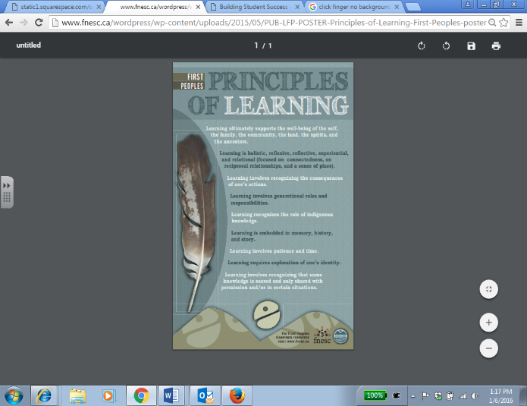http://www.clker.com/cliparts/Z/6/B/Y/s/N/pointer-finger-hi.pnghttp://www.clker.com/cliparts/Z/6/B/Y/s/N/pointer-finger-hi.png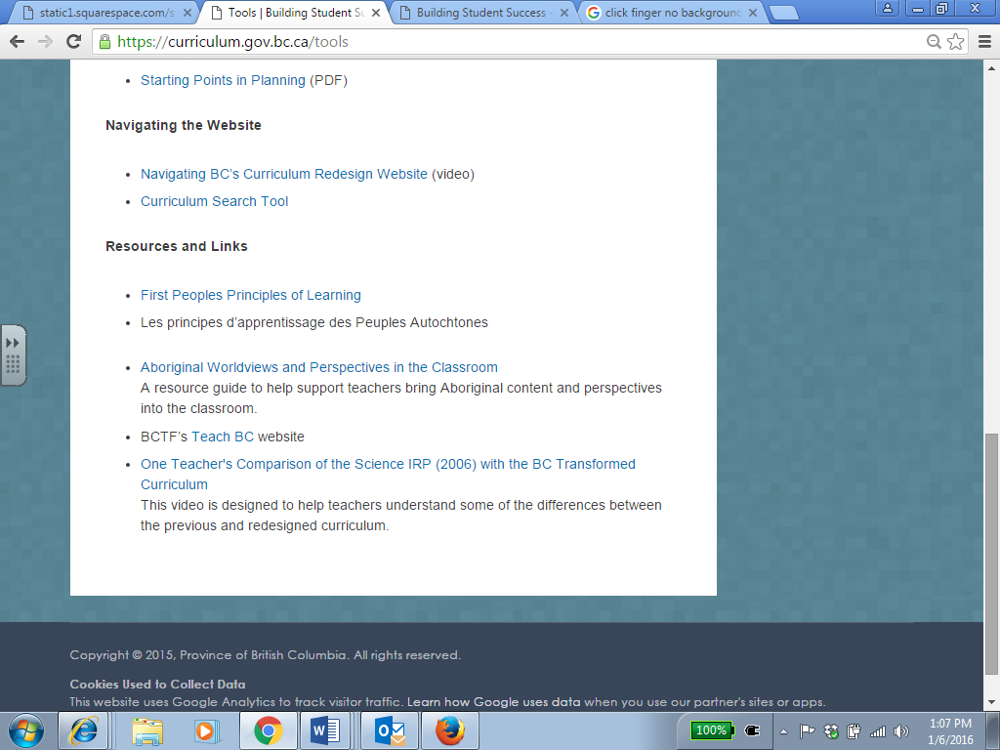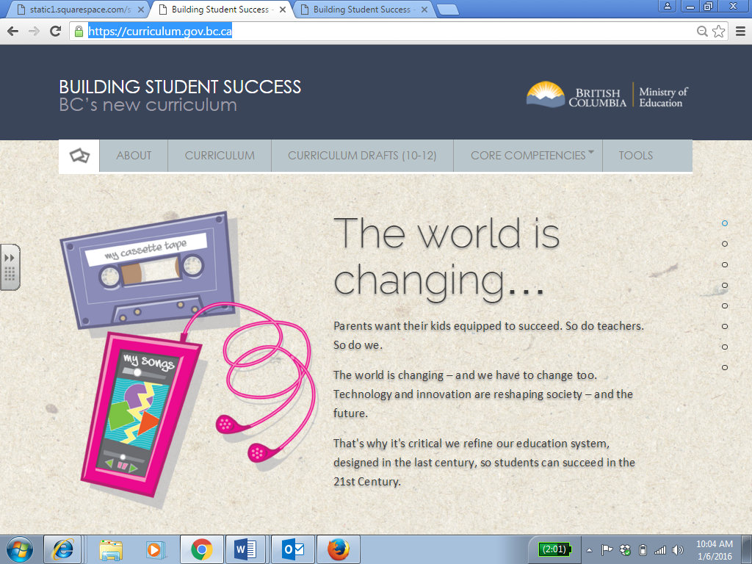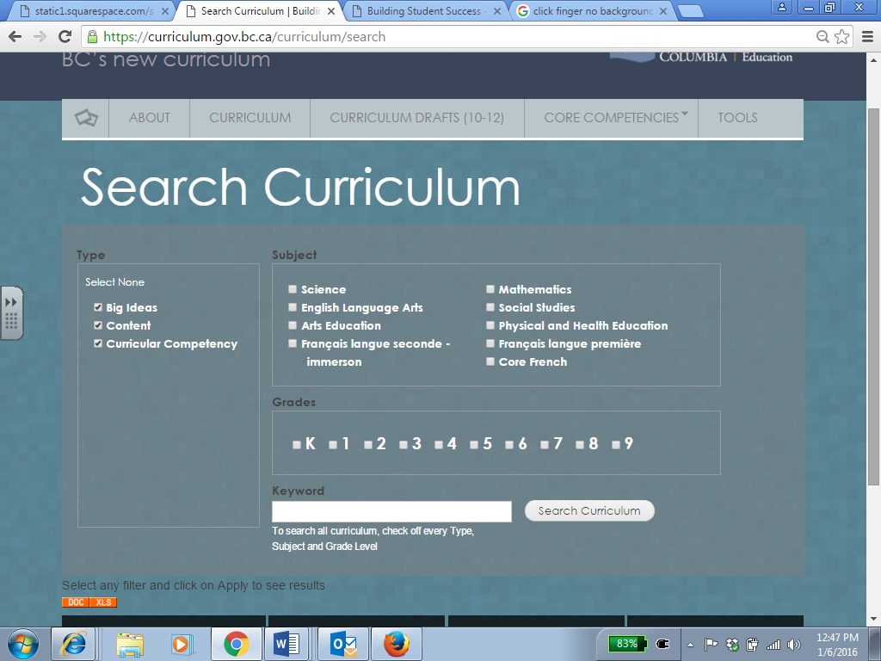http://www.clker.com/cliparts/Z/6/B/Y/s/N/pointer-finger-hi.png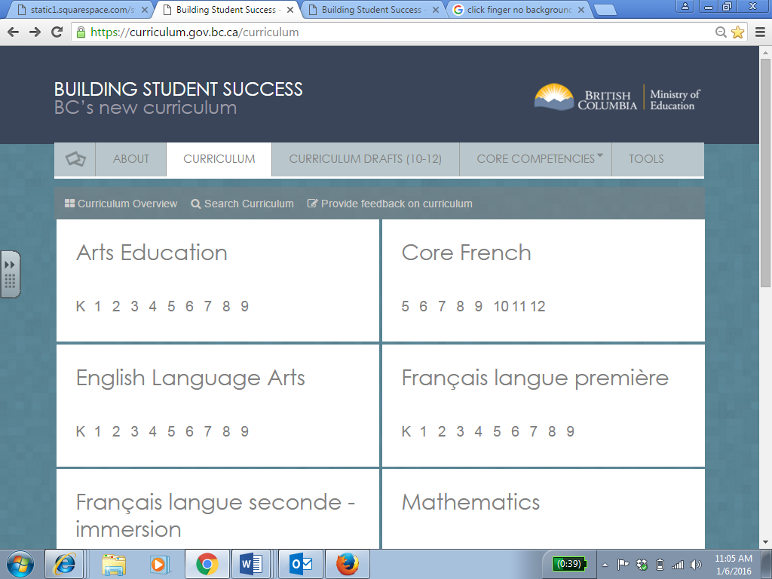http://www.clker.com/cliparts/Z/6/B/Y/s/N/pointer-finger-hi.pnghttp://www.clker.com/cliparts/Z/6/B/Y/s/N/pointer-finger-hi.png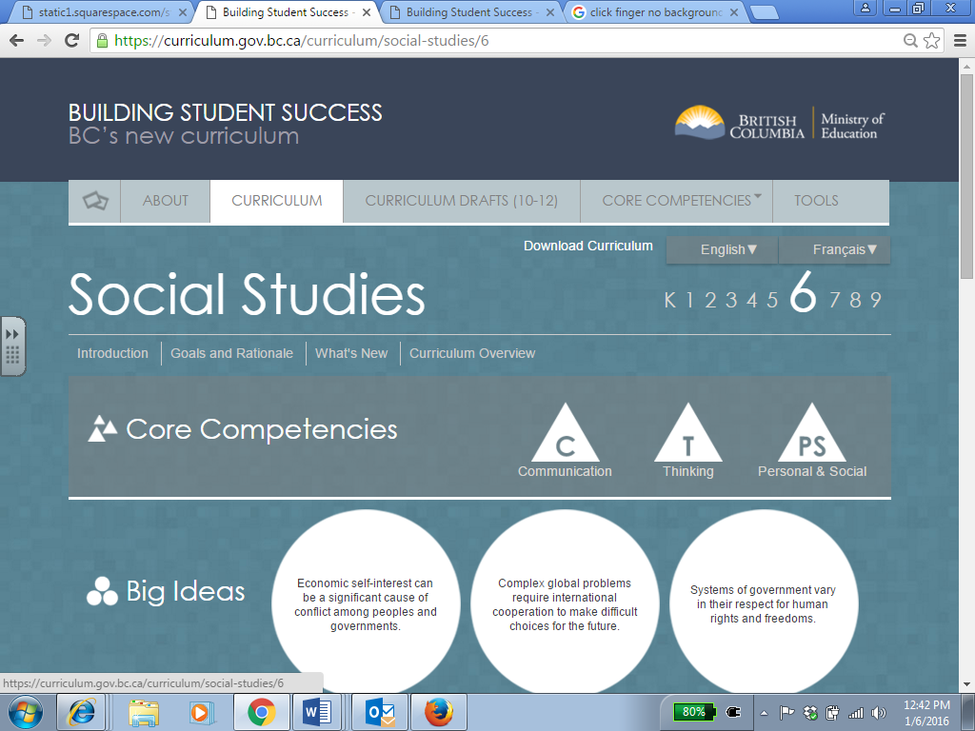http://www.clker.com/cliparts/Z/6/B/Y/s/N/pointer-finger-hi.png

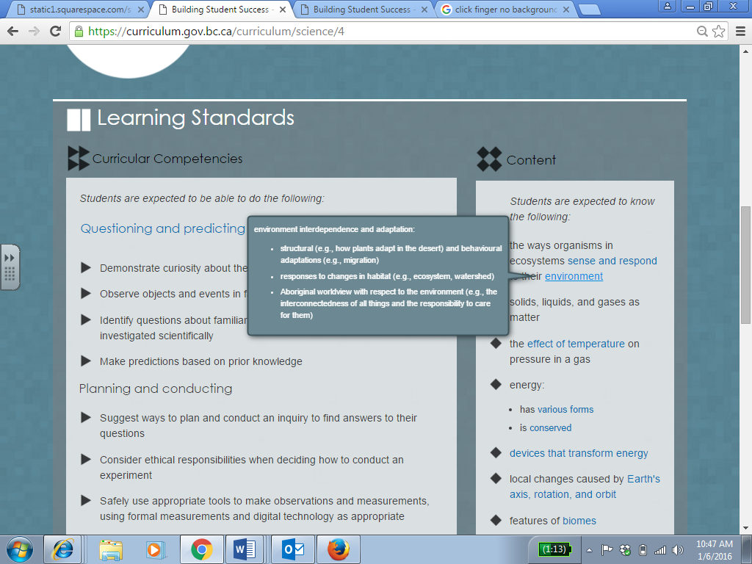

In your chosen subject hover over (or on a tablet click) the blue text.



TAKE NOTE:

These are called **Elaborations.** Elaborations can be definitions, explanation, examples, sample topics, or inquiry questions.

TASK:

Explore at least one elaboration in each category: Big Idea, Curricular Competency and Content. Discuss with your partner what you notice.

**4**

TASK:

Try these example searches (or come up with your own):

* In grade 5 search the term “resources” in Science and Socials to see some cross-curricular connections.
* Search “fractions” in Math 6,7,8 to see the progression of a concept over time.

**7**

TASK:

Choose one of these principles and connect it back to a Core Competency. Share your connection with your partner.

In the section titled “Resources and Links”, click the link called “First Peoples Principles of Learning”.

Click the “Tools” tab.

**6**

Under the “Curriculum” tab, click “Search Curriculum”.

TAKE NOTE:

You have to scroll down to see the results!

TAKE NOTE:

You can do searches within a grade/subject, cross-curricular or sequential over time. You can specify Big Idea, Content, Curricular Competencies or combinations. Elaborations will show up in your search results.

**5**

In your chosen subject locate these two tabs: “Goals & Rationale” and “Introduction”. Take a moment to click on each and skim the documents.

TASK:

* What are some important titles/headings in the Introduction?
* Pick one goal from Goals and Rationale and summarize it for your partner.

TAKE NOTE:

You may see important curricular elements in these sections!

Curriculum Exploration



Go to: <https://curriculum.gov.bc.ca/>http://www.clker.com/cliparts/Z/6/B/Y/s/N/pointer-finger-hi.png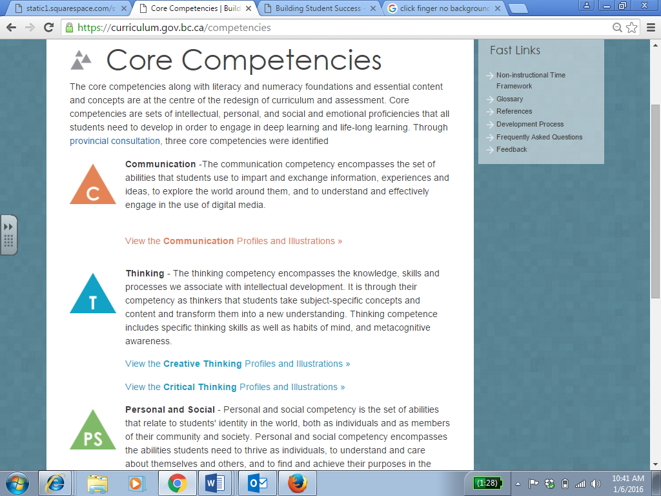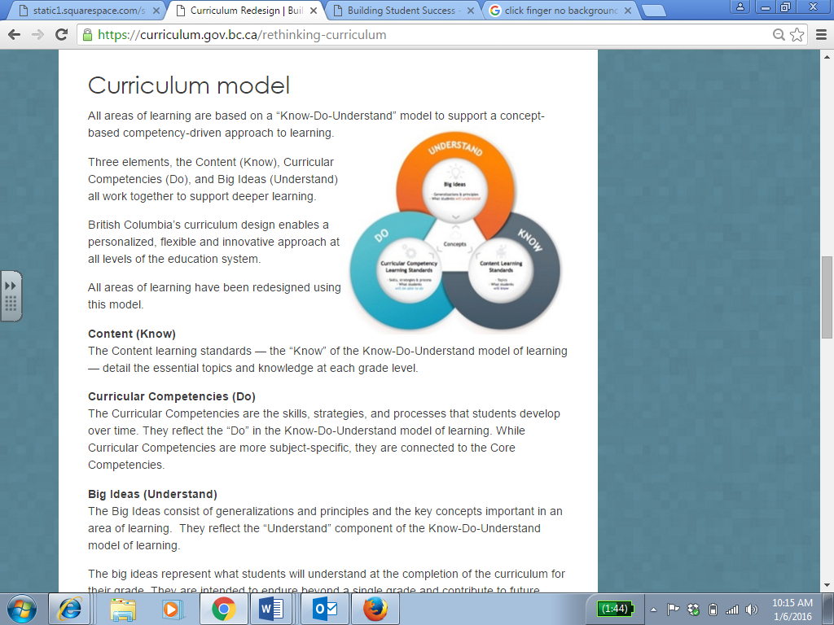http://www.clker.com/cliparts/Z/6/B/Y/s/N/pointer-finger-hi.png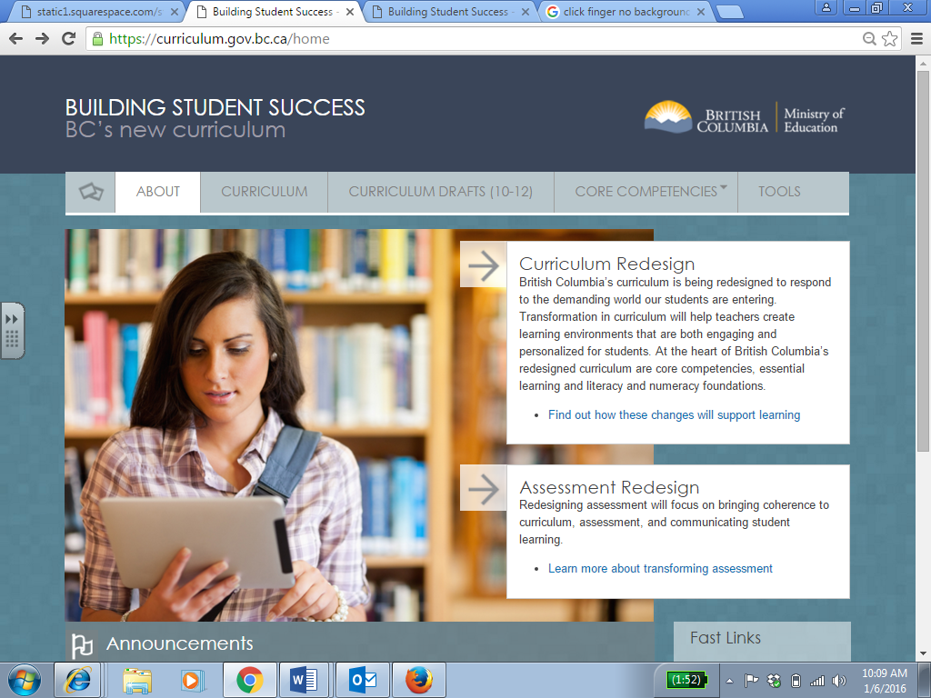http://www.clker.com/cliparts/Z/6/B/Y/s/N/pointer-finger-hi.pnghttp://www.clker.com/cliparts/Z/6/B/Y/s/N/pointer-finger-hi.png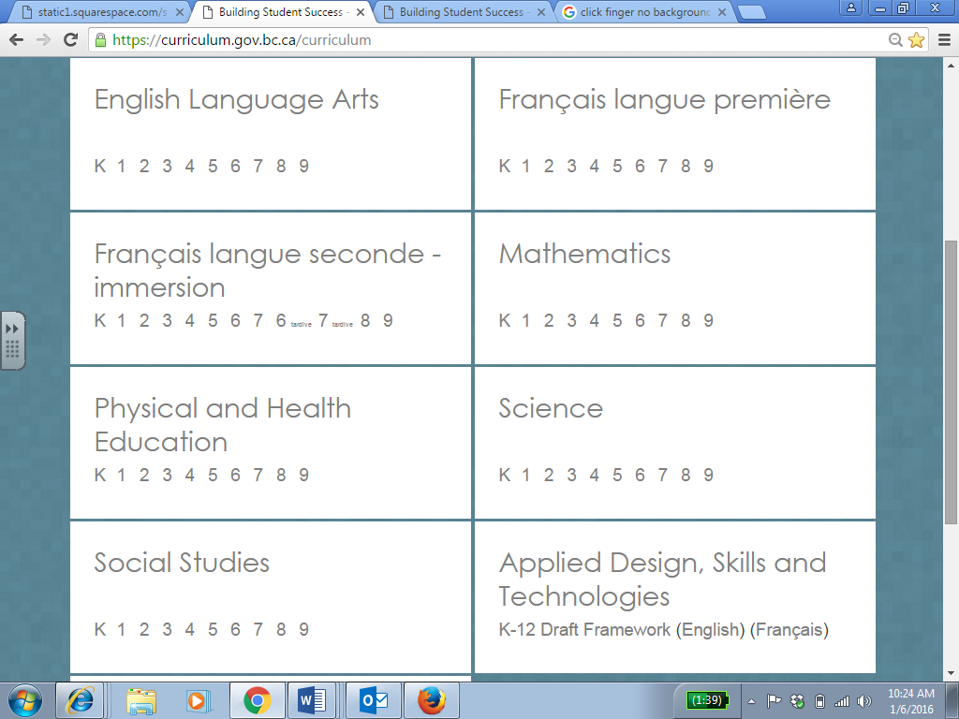http://www.clker.com/cliparts/Z/6/B/Y/s/N/pointer-finger-hi.png

TAKE NOTE:

The words Know, Do, and Understand are not the actual headings on this page

Click the “Core Competencies” tab. (on a tablet you may have to double-click).

**1**

TASK:

* Read these brief descriptions of the 3 Core Competencies.
* Discuss with your partner what these look like in your classroom.

TAKE NOTE:

There are more in-depth descriptions of the Core Competencies and examples available for further exploration!

**2**

TASK:

Read this section about the Curriculum Model.

TAKE NOTE:

There is a video about this in the ‘Tools” section!

Locate this image.

Click the link below:

Click the “About” tab.

Click the “Curriculum” tab.

Select a subject and grade.

TASK:

Scroll within your chosen subject and grade. How does the Know-Do-Understand model correspond to what is there and how it is set up? Discuss this connection and how it might look in your class.

**3**